
Name: ___________________ Aim: /42 or ____%
Target : /28 or ____%

Year 7 Geography (HASS) – Weighting 12.5%
Assessment 7 – Homework Task
Due: Week Three, Term Two

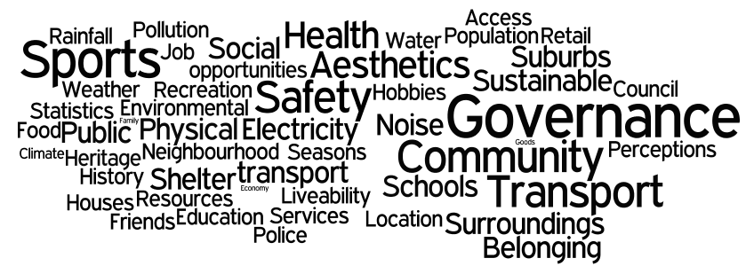
PART 1:

Study the WORDLE above. Using the WORDLE, select six words, which are essential to you when studying the liveability of an area? (3 marks)

My 6 words:

________________________________

________________________________

________________________________

________________________________

________________________________

________________________________

PART 2:

Using three words from your list above define these key words and provide an example in relation to liveability. (6 marks)

WORD 1: ______________________________

___________________________________________________________________________

___________________________________________________________________________

___________________________________________________________________________

___________________________________________________________________________

WORD 2: ______________________________

___________________________________________________________________________

___________________________________________________________________________

___________________________________________________________________________

___________________________________________________________________________

WORD 3: ______________________________

___________________________________________________________________________

___________________________________________________________________________

___________________________________________________________________________

___________________________________________________________________________

PART 3:

- Find and highlight the word ‘Perceptions’ on the WORDLE. (1 mark)

- Define the term ‘perception’ and provide an example for this word in relation to liveability. (3 marks)

___________________________________________________________________________

___________________________________________________________________________

___________________________________________________________________________

___________________________________________________________________________

- People often have different perceptions about areas in society.
Your task is to list down two different perceptions for the following areas in society that people or a group of people may have. You may like to undertake some fieldwork, by interviewing people and asking for their perception on the topic. (4 marks)

Your home town: __________________________________

Perception 1:

___________________________________________________________________________

___________________________________________________________________________

___________________________________________________________________________

Perception 2:

___________________________________________________________________________

___________________________________________________________________________

___________________________________________________________________________

A large city: __________________________________

Perception 1:

___________________________________________________________________________

___________________________________________________________________________

___________________________________________________________________________

Perception 2:

___________________________________________________________________________

___________________________________________________________________________

___________________________________________________________________________

PART 4: (6 marks)

Create a list of six factors that may influence a person’s decision about choosing a place to live. You may like to refer to the WORDLE for prompts to help you.

- _____________________________________________________________________

- _____________________________________________________________________

- _____________________________________________________________________

- _____________________________________________________________________

- _____________________________________________________________________

- _____________________________________________________________________

PART 5: Strategies to improve liveability

Using your home town as an example or you may select to look at your nearest town, write a paragraph about one strategy that has been used to enhance (improve) the liveability for young people. (5 marks)

___________________________________________________________________________

___________________________________________________________________________

___________________________________________________________________________

___________________________________________________________________________

___________________________________________________________________________

___________________________________________________________________________

___________________________________________________________________________

___________________________________________________________________________

